SINGLE INPUT, UNBALANCED OUTPUT DIFFERENTIAL AMPLIFIER
The circuit shown below is a dual-input balanced-output differential amplifier. Here in this circuit ,the input signals vin1, are applied to the bases B1 Q1 .The output vo is measured at C2..
Circuit Diagram:-
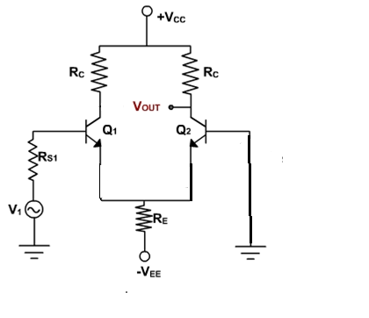

AC Analysis:-
To perform ac analysis to derive the expression for the voltage gains Ad and input resistance Ri of a differential amplifier:
1) Set the dc voltages +VCC and –VEE at 0
2) Substitute the small signal re equivalent models for the transistors

Figure below shows resulting ac equivalent circuit of the single input unbalanced output differential amplifier
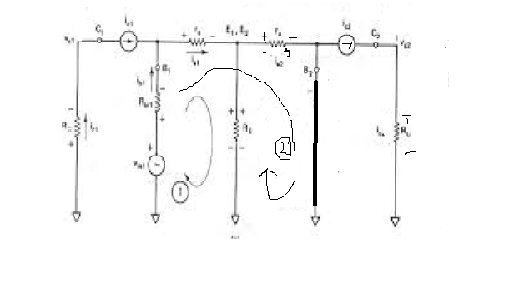
AC EQUIVALENT CIRCUIT FOR DUAL-INPUT BALANCED OUTPUT DIFFERETIAL AMPLIFIER
Writing Kirchhoff’s voltage equations for loops 1 and 2 gives us

v_{in1} – R_{in1}i_{b1} – r_{e}i_{e1} – R_{E} (i_{e1-}i_{e2}) = 0 (1)

v_{in1} – R_{in1}i_{b1} – r_{e}i_{e1} -r_{e}i_{e2} = 0 (2)

Substituting current relations i_{b}1 = i_{e1}/β _{ac} yields
v_{in1} – R_{in1} i_{e1}/β _{ac} – r_{e}i_{e1} – R_{E} (i_{e1}+i_{e2}) = 0 (3)

v_{in1} – R_{in1} i_{e1}/β _{ac} – r_{e}i_{e1} -r_{e}i_{e2} –= 0 (4)

Generally, R_{in1}/β _{ac} values are very small therefore we shall neglect them here for simplicity and rearrange these equations as follows:

(r_{e}+R_{E}) i_{e1} -R_{E}i_{e2} = v_{in1} (5)

r_{e}i_{e1} + r_{e}i_{e2} = v_{in1} (6)

Eqns (5) and (6) can be solved simultaneously for ie1 and ie2 by using Cramer’s rule:
i_{e1}= $\frac{\left|\begin{matrix}vin1 & -RE \\ vin1 & re\end{matrix}\right|}{\left|\begin{matrix}(re+RE) & -RE \\ re & re\end{matrix}\right|}$

i_{e2}= $\frac{\left|\left|\begin{matrix}(re+RE) & vin1 \\ re & vin1\end{matrix}\right|\right|}{\left|\begin{matrix}(re+RE) & -RE \\ re & re\end{matrix}\right|}$

i_{e1 =} [ v_{in1} (r_{e})+ v_{in1}R_{E}]/[ r_{e} (r_{e}+2R_{E})]

i_{e1 =} [ v_{in1} (r_{e}+ R_{E})]/[ r_{e} (r_{e}+2R_{E})] (7) and

i_{e2 =} [ v_{in1} (r_{e}+R_{E})- v_{in1}r_{e}]/[ r_{e} (r_{e}+2R_{E})]

i_{e2 =} [ v_{in1} R_{E}]/[ r_{e} (r_{e}+2R_{E})] (8)

The output voltage is
v_{o} = v_{c2}
=R_{C}i_{c2} (9)
= R_{C}i_{c2}
Substituting current relations in eqn(9), Generally,RE>>re, which implies that (re+2RE) = 2RE and (re+RE) = RE.
we get
vo = = (RC/2re) (vin1 )
we can write the voltage-gain equation of the single-input unbalanced-output differential amplifier as follows:
A_{d} = v_{o} /vin = R_{C}/2r_{e} (10)
Differential Input Resistance:-
Differential input resistance is defined as the equivalent resistance that would be measured at either input terminal with the other terminal grounded.
Ri1 = |vin1/ib1|Vin2=0
=|vin/(ie1/βac)|Vin2=0
Substituting the value of ie1, we get
Ri1 = βacvin1/[{(re+RE)vin1/ r_{e} (r_{e}+2R_{E})}] (11)
=[βac(re²+2reRE)]/(re+RE)
=[βac re(re+2RE)]/(re+RE)
Generally,RE>>re, which implies that (re+2RE) = 2RE and (re+RE) = RE.
Therefore eqn(11) can be rewritten as
Ri1 = βacre(2RE)/RE = 2βacre (12)
Output Resistance:-
Output resistance is defined as the equivalent resistance that would be measured at either output terminal w.r.t ground.
Ro1 = Ro2 = R_{C} (13)
.

